Film Resource Type

* Condition 1: LDR ^.{6}g
  + This looks for LDR:06=g (projected medium)
* Condition 2: AND 008 ^.{33}m
  + This looks for 008:33=m (motion picture)
* Condition 3: AND 008 ^.{29}[a-np-zA-NP-Z0-9 #] (note that this includes a space before the #.)
  + This looks for 008:29 that is not = o (online)

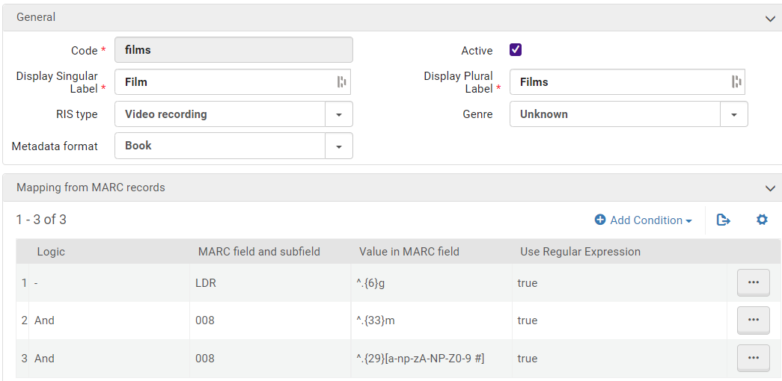

Once you’ve set a local resource type up, you’ll need to gather up your IZ-only bibs that are included in that type and run the “Recalculate Resource Types” job on them.  If you’re planning to apply multiple types at the same time, you can hold this step and run the job on ALL of your IZ-only bibs at once after you complete setup of all local resource types.